Ross Hoffman 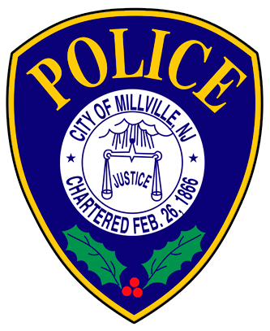 Sherman Taylor
Chief of Police Director of Public Safety

Millville Police Department
Physical Fitness Assessment Testing

Injury Waiver Form

Applicant: ___________________
DOB: ___________________
Signature: ___________________
Date: ___________________

By signing your name above as applicant with the Millville Police Department and City of Millville, you acknowledge that participation in the Millville Police Department’s fitness assessment test exposes you of the possibility of personal injury. You being fully aware that participation in the fitness assessment test exposes you to the possible risk of personal injury, hereby release the Millville Police Department, Officers, and the City of Millville from any and all liability from property damage, personal injuries, or other claims that are known and unknown.

You acknowledge that you fully understand this Injury Waiver Form. This agreement shall be binding on you, and all relatives, and/or legal representatives.

Thank you,

Sergeant Ralph Satero
Millville Police Department
Training Unit

